**PROJECT REPORT**

1. **INTRODUCTION**

1.1 Overview

Project Name: IMPLEMENTING CRM FOR RESULT TRACKING WITH INTERNAL MARKS

Administrator should be able to create all base data including Semester, Candidate, Course and Lecturer, Lecturer should have the ability to create Internal Results, Dean, who is one of the Lecturer, should be the only one with the ability to update Internal Results. Re-evaluation can be initialised by Candidate for all Internal Results. Now only dean can update the marks after re-evaluation.

1.2 Purpose

CRM for result tracking with internal marks is used to track Candidates Internal results effectively and easily .It is used to monitor Candidates progress and details. It also provides other details such as Course details, Lecturer details for detailed administration.

1. **PROBLEM DEFINITION AND DESIGN THINKING**
   1. Empathy Map

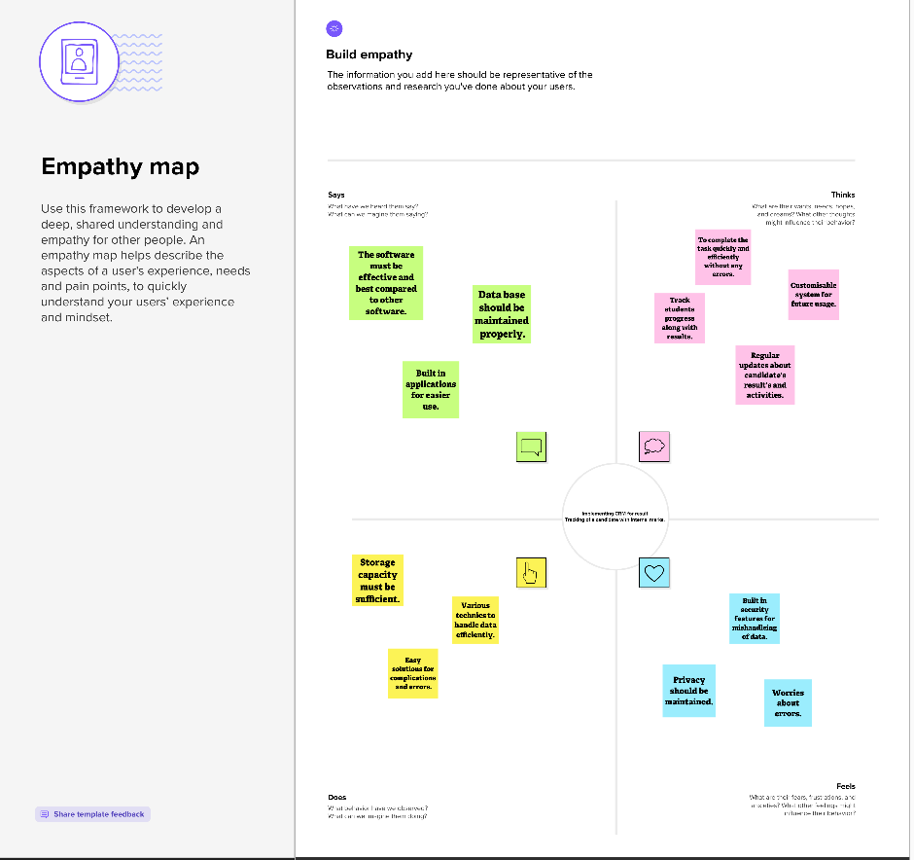

* 1. Ideation and Brainstorming

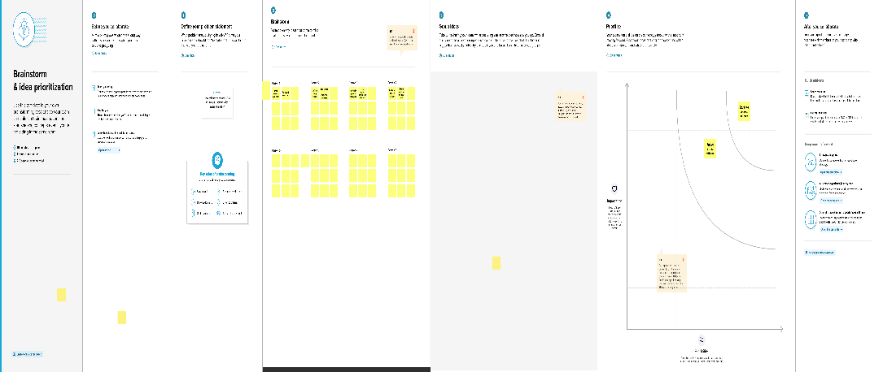

**3. RESULT**

3.1 Data Model

|  |  |
| --- | --- |
| Object Name | Fields In The Object |
| Semester | |  |  | | --- | --- | | Field label | Data Type | | Semester Name | Text | |
| Course Details | |  |  | | --- | --- | | Field Label | Data Type | | Course Name | Text | | Course Id | Text | |

3.2 Activity and Screenshot

Milestone 1: Creating Developer Account.

Go to developer.salesforce.com and sign up by entering the details. After signing up go to your mailbox and activate your account by clicking on verify account. Then log in to your salesforce account. After logging in you will see the home page.

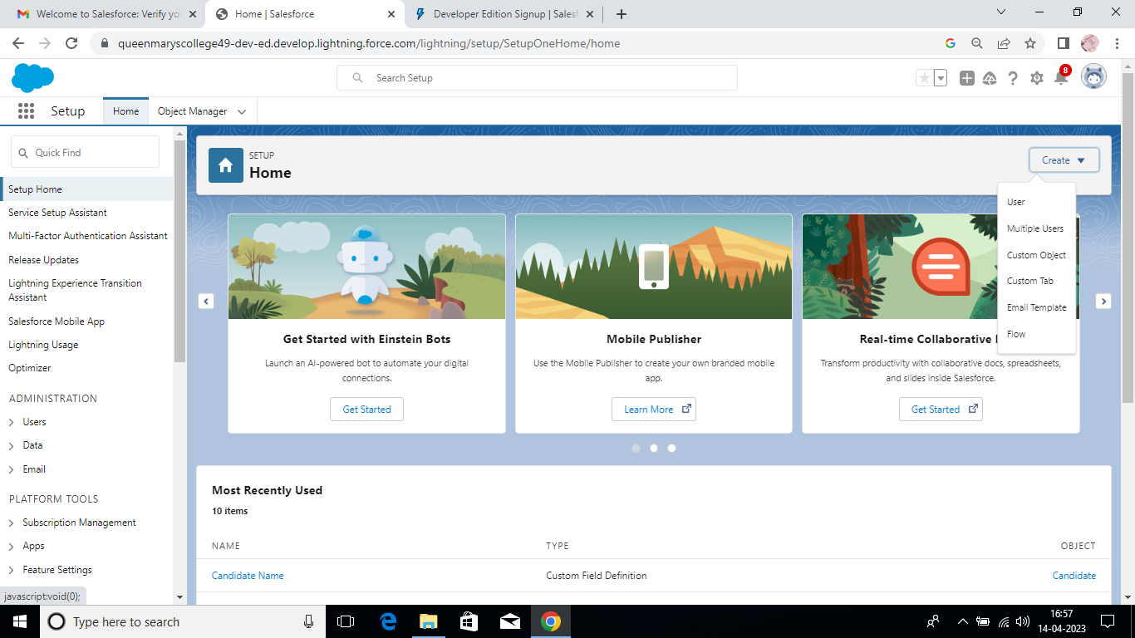

Milestone 2: Creation of Objects and Fields

Salesforce objects are database tables that permit you to store data that is specific to an organisation. Standard objects are the kind of objects that are provided by salesforce.com such as users, contracts, reports, dashboards etc. Relationships are created by creating custom relationship fields on an object. This is done so that when users view records, they can also see and access related data.

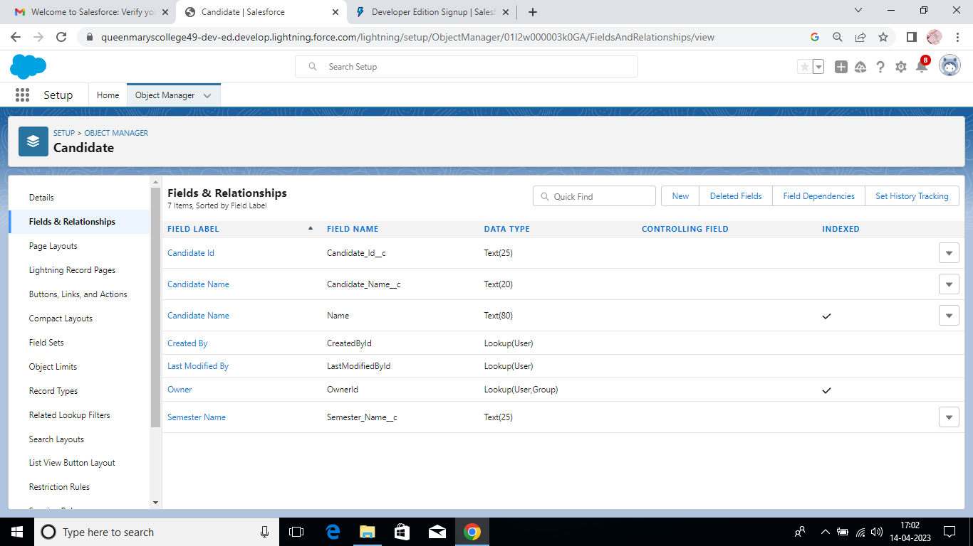

Milestone 3: Creation of Candidate Internal Result Card App

Apps in Salesforce are a group of tabs that help the application function by working together as a unit. It has a name, a logo, and a particular set of tabs. The simplest app usually has just two tabs.

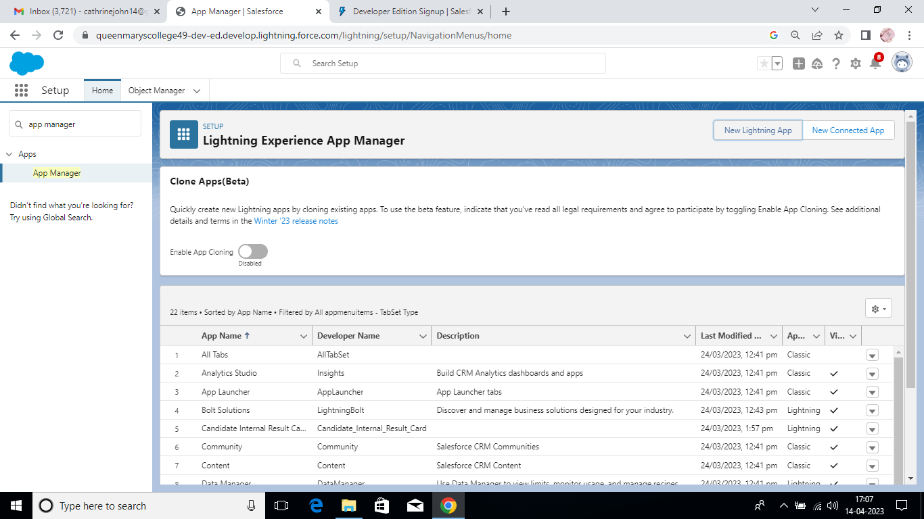

Milestone 4: Creating a User Profile.

A user is anyone who logs in to Salesforce. Users are employees at your company, such as sales reps, managers, and IT specialists, who need access to the company's records. Every user in Salesforce has a user account.

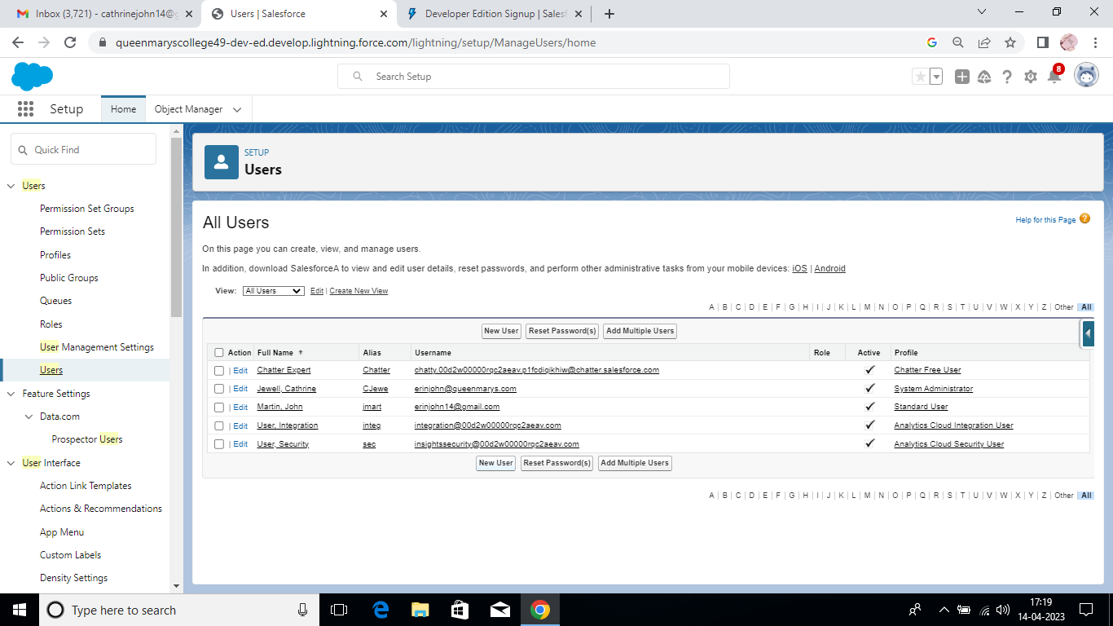

Milestone 5: Report

A report is a list of records that meet the criteria you define. It's displayed in Salesforce in rows and columns, and can be filtered, grouped, or displayed in a graphical chart. Every report is stored in a folder. Folders can be public, hidden, or shared, and can be set to read-only or read/write.

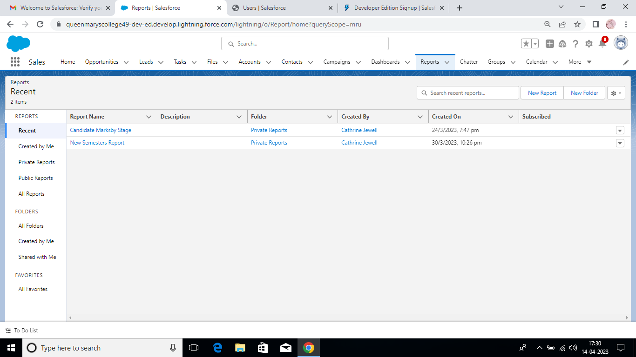

Milestone 6: Dashboards

Dashboards let you curate data from reports using charts, tables, and metrics. If your colleagues need more information, then they're able to view your dashboard's data-supplying reports. Dashboard filters make it easy for users to apply different data perspectives to a single dashboard.

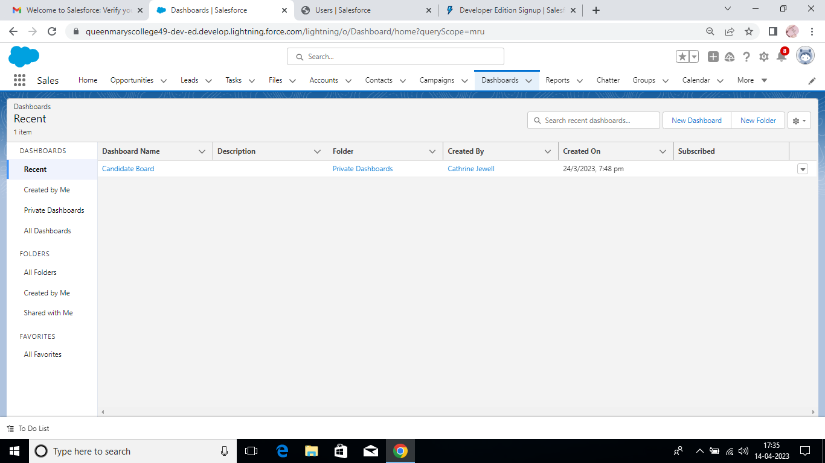

1. **TRAILHEAD PROFILE PUBLIC URL**

**Team Leader – https://trailblazer.me/id/divyam22**

**Team Member 1 -https:// trailblazer.me/id/brajaraman1**

**Team Member 2 –** **https://trailblazer.me/id/cathy1416**

**Team Member 3 –** **https://trailblazer.me/id/dhesm1**

1. **ADVANTAGES AND DISADVANTAGES**

**Advantages:**

* It helps in tracking Candidates Results and Progress.
* It helps to maintain large data.
* It speeds up the process for Users.
* It allows for the consolidation of customers data and the basis for deep insights.

**Disadvantages**:

* It requires proper training to handle the software.
* Security Issues and Third Party Access.
* Dependent on Proper Setup.
* It is Expensive.

1. **APPLICATIONS**

It is used by Universities, Schools and Colleges to track Candidate results and Progress. It is used to manage large data. It is also used by many educational institutions to track results.

1. **CONCLUSION**

In this project we created a developer account and created custom objects and fields for the objects. Then we created a Candidate Internal Result Card App. Later we created a user profile with the given details. Finally we created a report for Candidate marks and then created a new dashboard at the end.

1. **FUTURESCOPE**

A detailed project Manual with pictorial representation can be implemented along with solutions for frequently asked questions for better understanding of the project.